Supplementary material

Cite this document as:
Abdo, HG. Evaluating the potential soil erosion rate based on RUSLE model, GIS, and RS in Khawabi river basin, Tartous, Syria. DYSONA – Applied Science, 2022;1(1): 24-32. doi: 10.30493/das.2021.311044

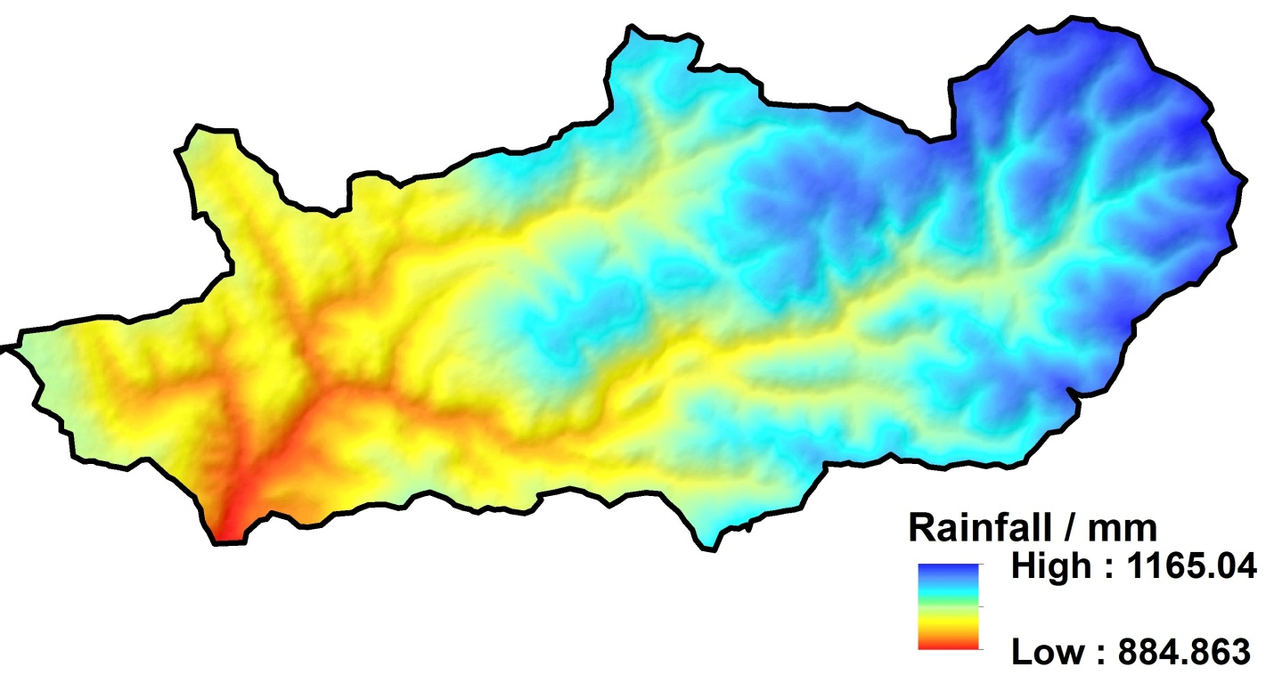
Supplementary Figure 1. Spatial distribution of rainfall values in Khawabi river basin.

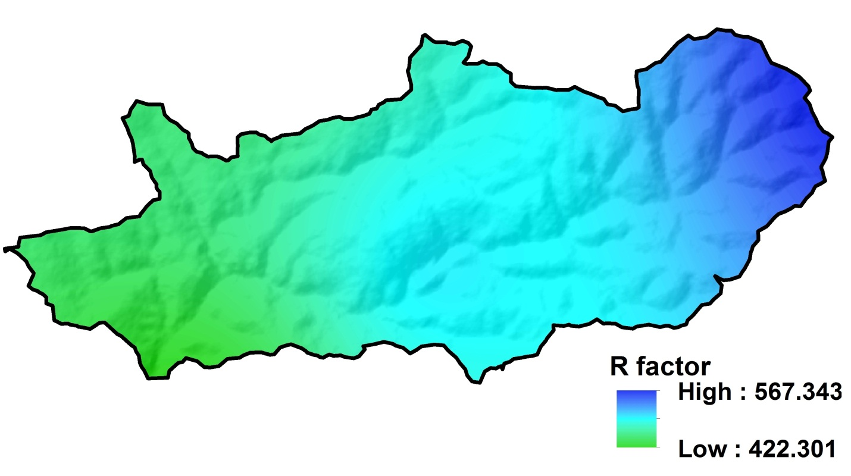
Supplementary Figure 2. Spatial distribution of rainfall erosivity (R) factor values in Khawabi river basin.

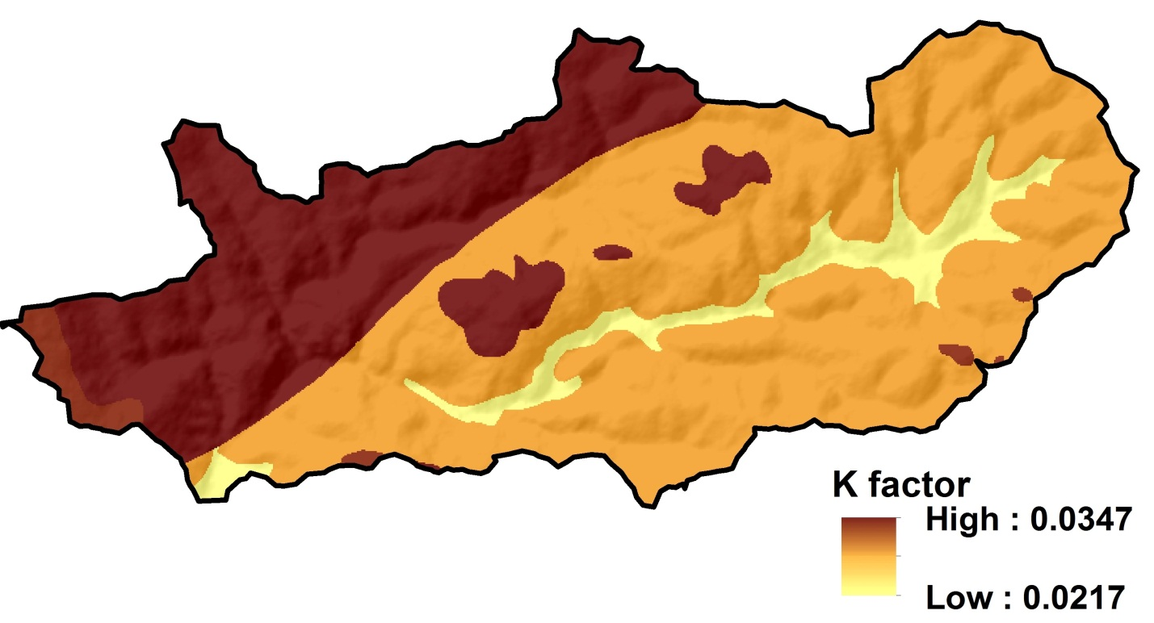

Supplementary Figure 3. Spatial distribution of soil erodibility (K) factor values in Khawabi river basin.

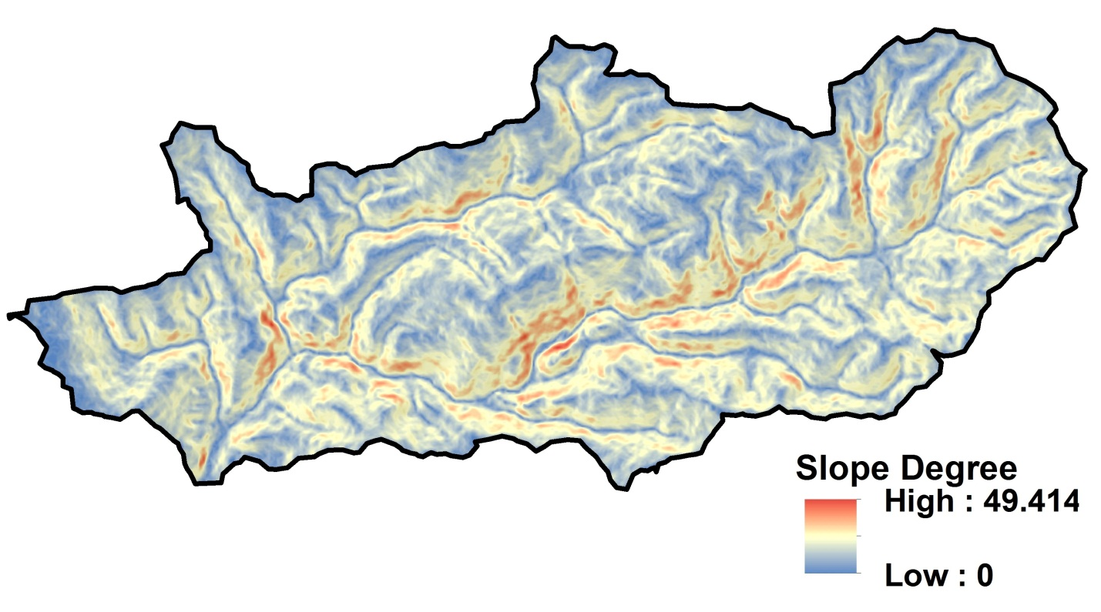

Supplementary Figure 4. Spatial distribution of slope values in Khawabi river basin.

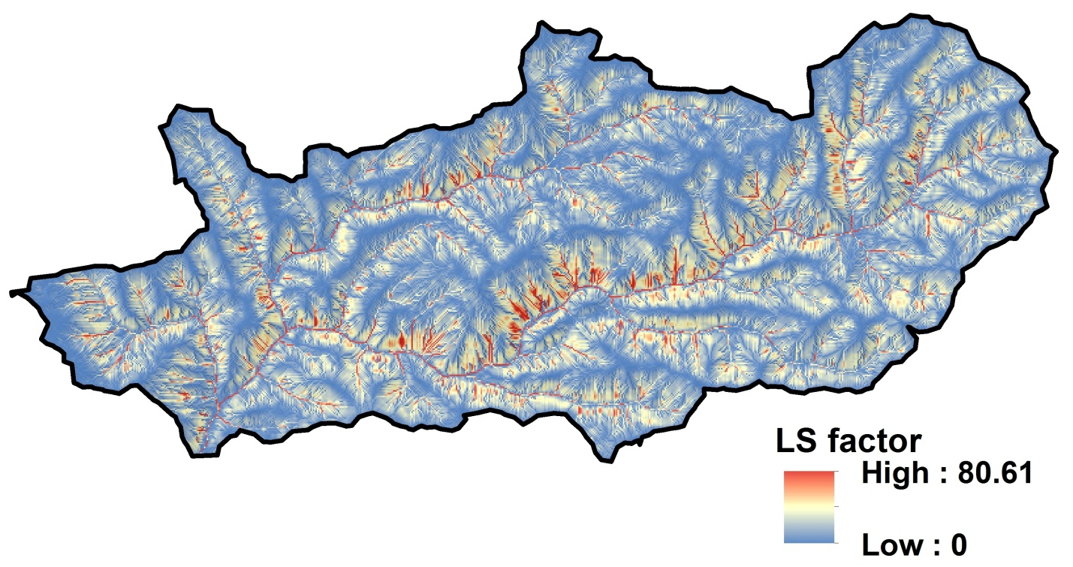
Supplementary Figure 5. Spatial distribution of hill slope and steepness (LS) factor values in Khawabi river basin.

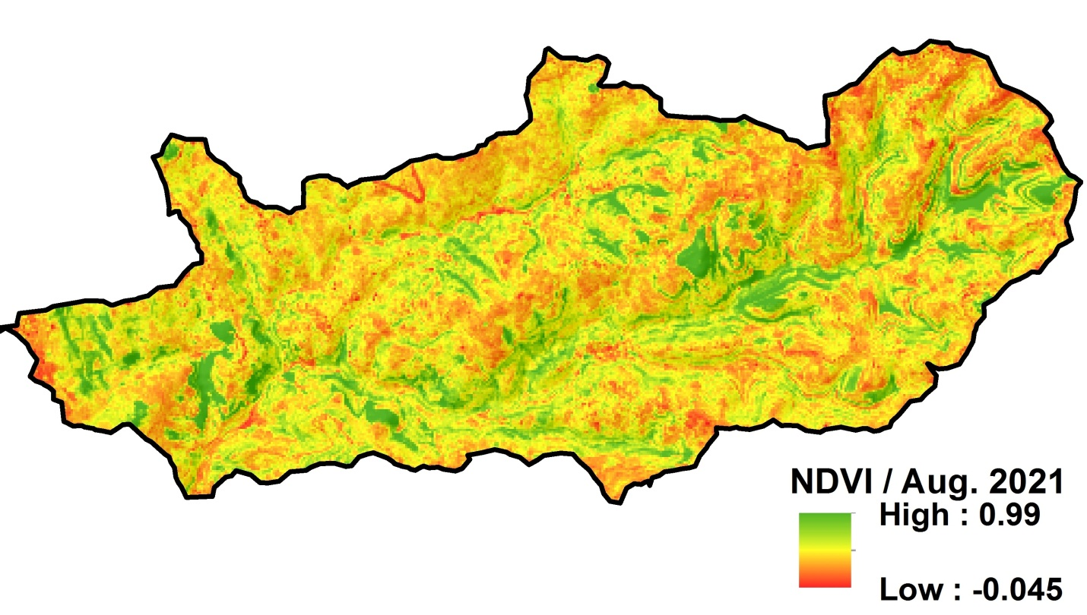
Supplementary Figure 6. Spatial distribution of normalized difference vegetation index (NDVI) values in Khawabi river basin.

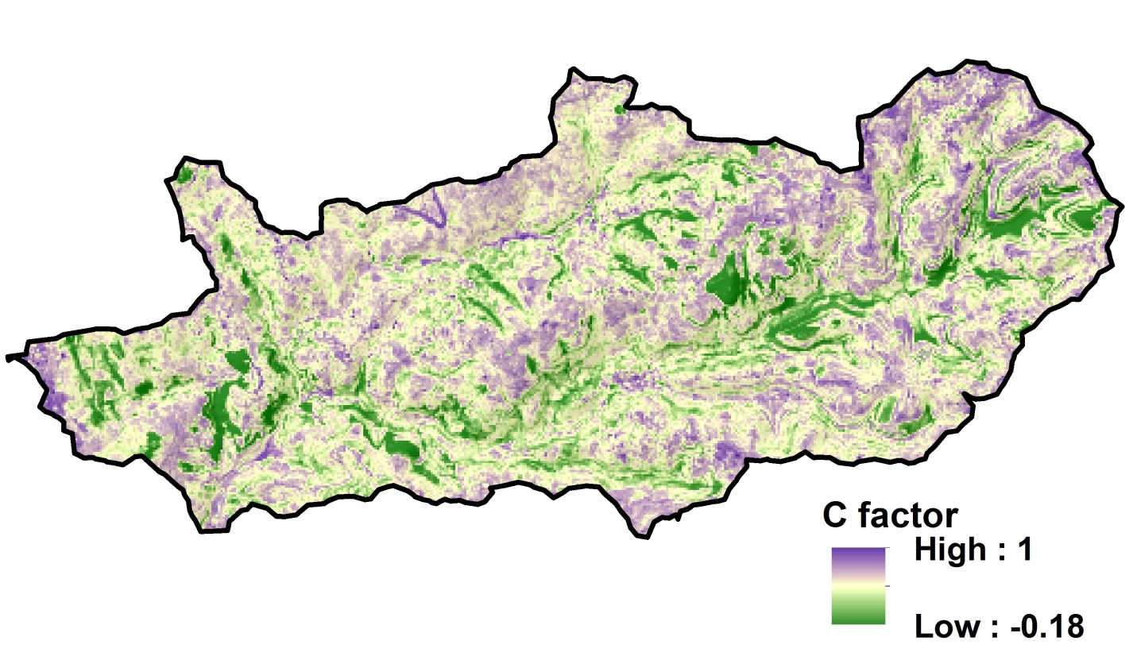
Supplementary Figure 7. Spatial distribution of vegetation (C) factor values in Khawabi river basin.

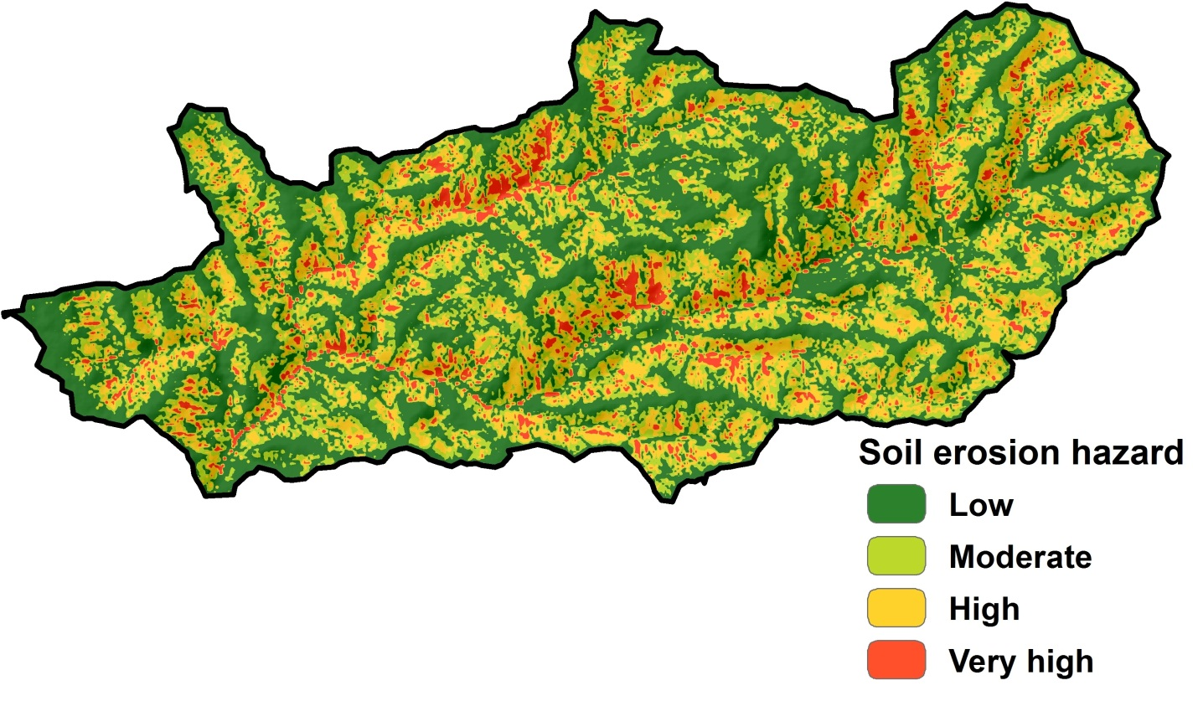

Supplementary Figure 8. Spatial distribution of soil erosion values in Khawabi river basin.

